**BUS RESERVATION SYSTEM**

**EXPERIMENT-6**

**To perform the user’s view analysis:**

**Use case diagram. (Based on interview management system)**

**Table of Contents:**

1. Introduction

2. Objectives

3. Scope

4. Use Case Diagram

5. Use Case Descriptions

6. Summary

**1. Introduction**

This document provides a comprehensive analysis of the user's view for a Bus reservation system . The system aims to enhance the experience of commuters by providing real-time bus location information, improving operational efficiency, and facilitating better management of bus routes and schedules. This document includes a use case diagram based on stakeholder requirements gathered through discussions and workshops.

**2. Objectives**

- To understand and document the user requirements for the Bus reservation system .

- To visualize the interactions between users and the system through a use case diagram.

- To provide a clear and concise reference for developers and stakeholders.

**3. Scope**

The scope of this document covers the following:

- Identifying primary actors interacting with the Bus reservation system .

- Defining the main use cases for the Bus reservation system .

- Creating a use case diagram to represent the user's view of the system.

- Providing detailed descriptions of each use case.

**4. Use Case Diagram**

The use case diagram represents the interactions between users and the Bus reservation system . It identifies the primary actors and key functionalities that the system provides. The primary actors include Commuters, Bus Operators, Administrators, and Maintenance Staff.

**Actors:**

- Commuter

- Bus Operator

- Administrator

- Maintenance Staff

**Use Cases:**

- Track Bus Location

- View Bus Schedule

- Receive Alerts

- Manage Bus Routes

- UPDATE

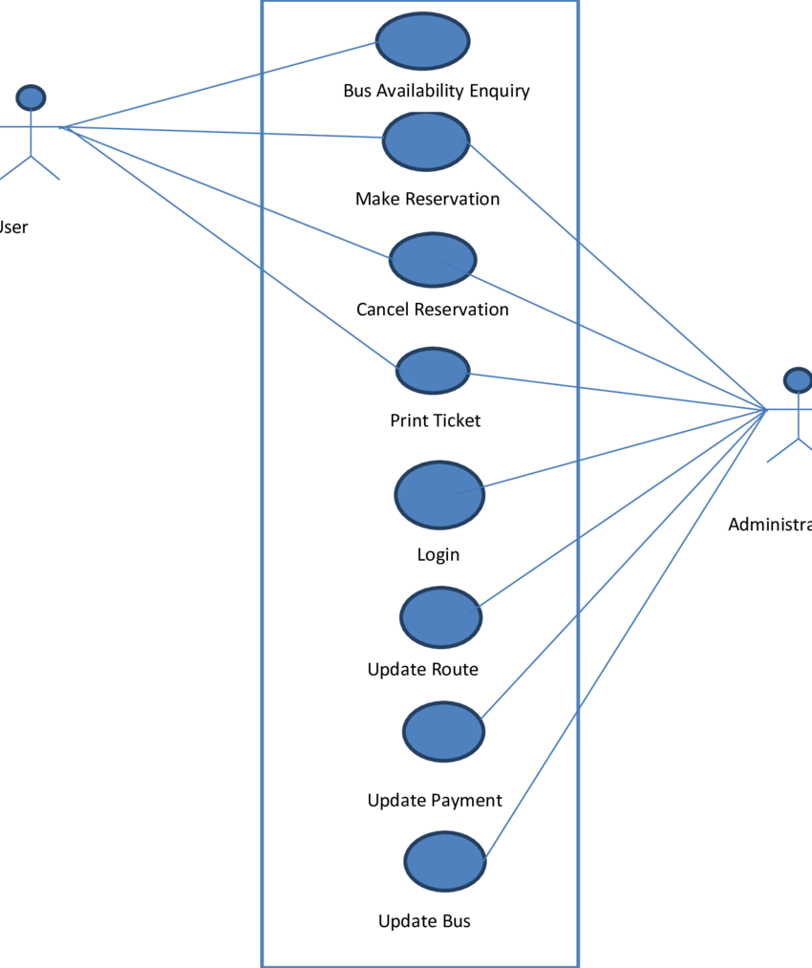

**Relationships:**

- Commuter interacts with: Track Bus Location, View Bus Schedule, Receive Alerts.

- Bus Operator interacts with: Track Bus Location, Manage Bus Routes.

- Administrator interacts with: Manage Bus Routes, View Reports.

- Maintenance Staff interacts with: Report Issues, View Reports.

**5. Use Case Descriptions**

**5.1 Track Bus Location**

- Actor: Commuter

- Description: Commuters can track the real-time location of buses on their route using the mobile

**5.2 View Bus Schedule**

**- Actor:** Commuter

**- Description:** Commuters can view the schedules for buses, including arrival times and routes, to plan their journeys.

**5.3 Receive Alerts**

- **Actor**: Commuter

**- Description:** Commuters receive alerts about delays, route changes, or other important information regarding their bus routes.

**5.4 Manage Bus Routes**

**- Actor:** Bus Operator, Administrator

**- Description:** Bus operators and administrators can manage bus routes, update schedules, and optimize routes based on commuter feedback and operational needs.

**5.5 UPDATES**

**- Actor:** Maintenance Staff

**- Description**: Maintenance staff can report and track issues related to buses, such as mechanical problems or cleanliness issues.

**6. Summary**

This document has outlined the user requirements and functionalities of the Bus reservation system . By detailing the use cases and interactions, it provides a comprehensive guide for development and stakeholder understanding.

This adaptation aligns the structure and content with a Bus reservation system , focusing on functionalities related to tracking buses, managing schedules, and enhancing commuter experience.